ASSIGNMENT : 5
1.
Create a new IAM user in your chosen cloud provider (AWS, Azure, or GCP) named 'foodieAppTester' and assign only the permissions needed to list storage buckets or containers, but not to create or delete them.<br><br><em><strong>Hint:</strong> Use built-in roles like 'Storage Viewer' or create a custom policy with only 'list' actions.</em>
ANS :
Screenshot : The IAM user foodieAppTester was created successfully in AWS IAM to provide controlled access to S3 bucket listing.

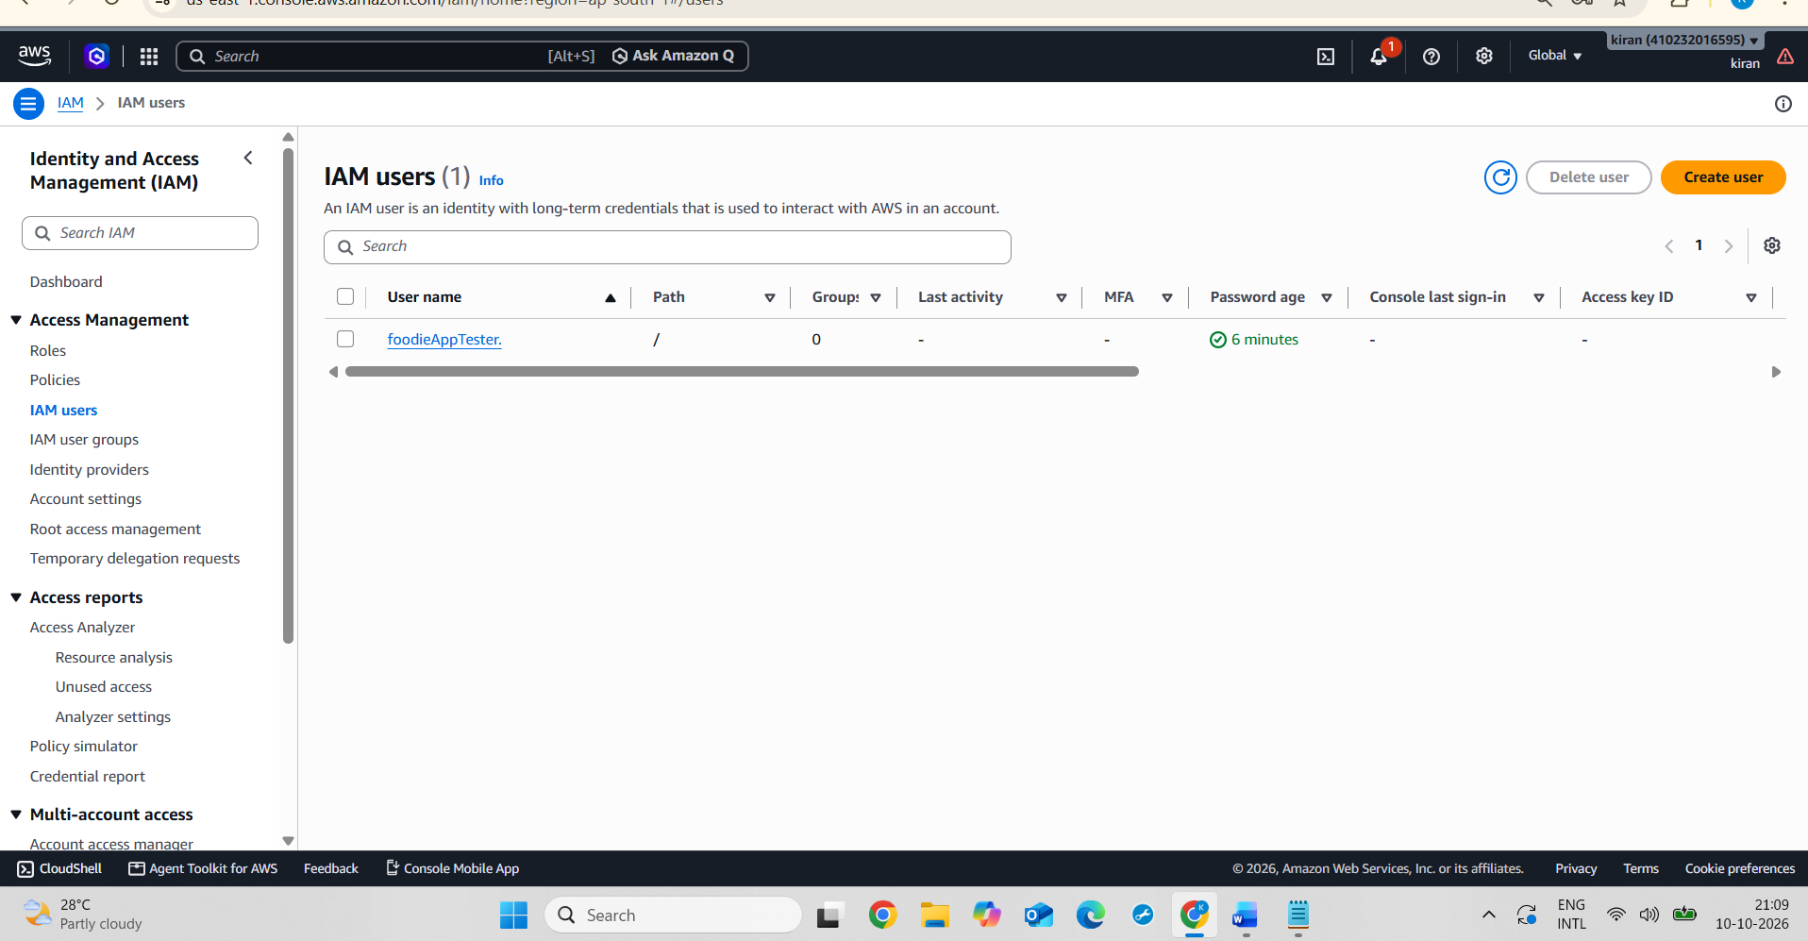
Screenshot : A custom IAM policy named FoodieAppTesterListBucketsOnly was created using the s3:ListAllMyBuckets permission to allow listing S3 buckets without granting permission to create or delete buckets.

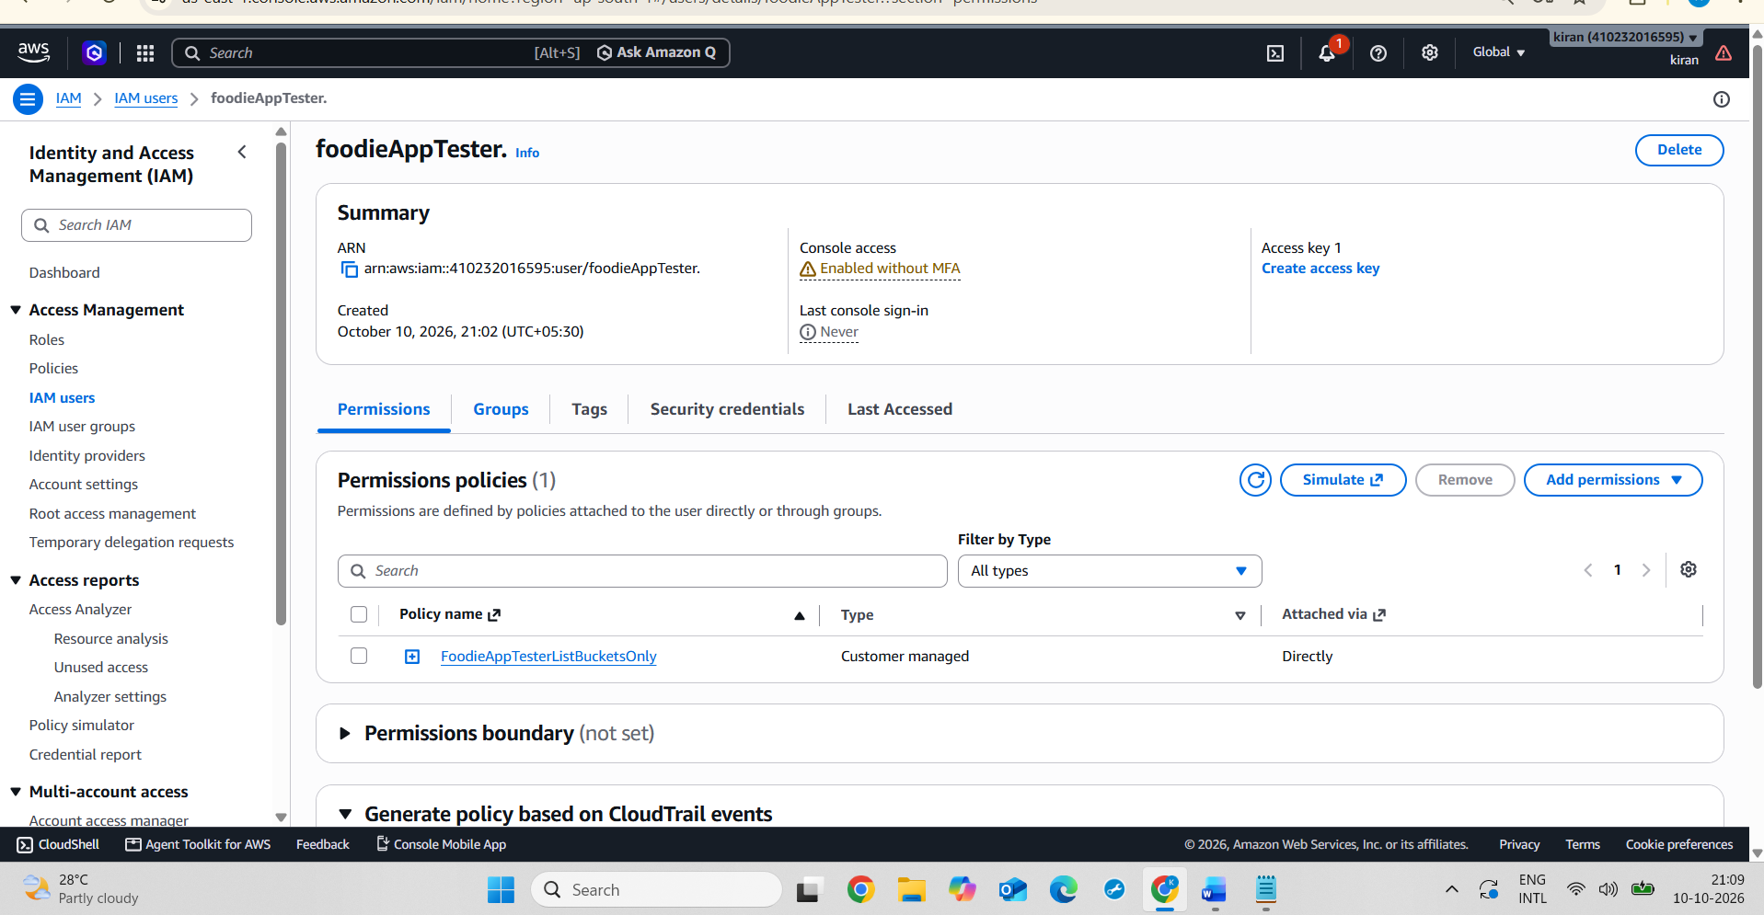
Screenshot :The custom IAM policy FoodieAppTesterListBucketsOnly was attached to the foodieAppTester user, following the principle of least privilege by granting only the required bucket-listing permission.

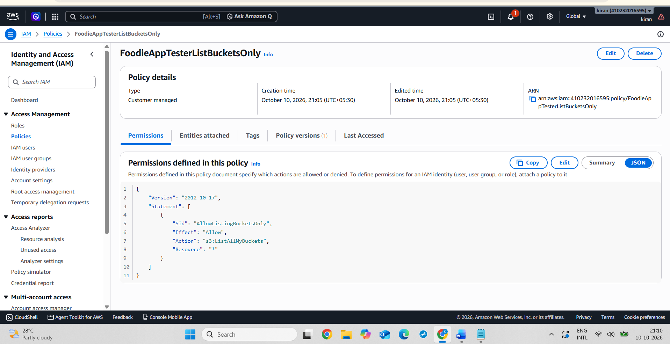
2.
Audit the permissions of an existing IAM user or role in your cloud account and identify at least two permissions that are broader than necessary for a Zomato-style food delivery app backend (for example, full access to all services instead of just database and storage read/write).
ANS :
IAM Permission Audit for a Zomato-Style Food Delivery App
Objective: To audit an existing AWS IAM role and identify permissions that may be broader than necessary for a food delivery application.
Role Audited: EC2-SSM-Role
1. Permission Audit Findings
Finding 1: Systems Manager Permissions
The policy allows ssm:GetParameter and ssm:GetParameters with "Resource": "*". This may allow access to parameters beyond those required by the application.
Recommendation: Restrict access to the specific Parameter Store resources required by the application.
Finding 2: EC2 Messages Permissions
The policy allows multiple ec2messages actions with "Resource": "*". These permissions should be reviewed to determine whether all are necessary.
Recommendation: Keep only the permissions required for the EC2 Systems Manager workflow.
2. Security Recommendation
Follow the principle of least privilege by granting only the permissions required for the application's tasks and restricting access to specific resources wherever possible.
3. Conclusion
The audit identified two areas where permissions should be reviewed to reduce unnecessary access. Applying least-privilege permissions can improve the security of the food delivery application's cloud infrastructure.
Screenshot : IAM role selected for the permission audit in AWS.
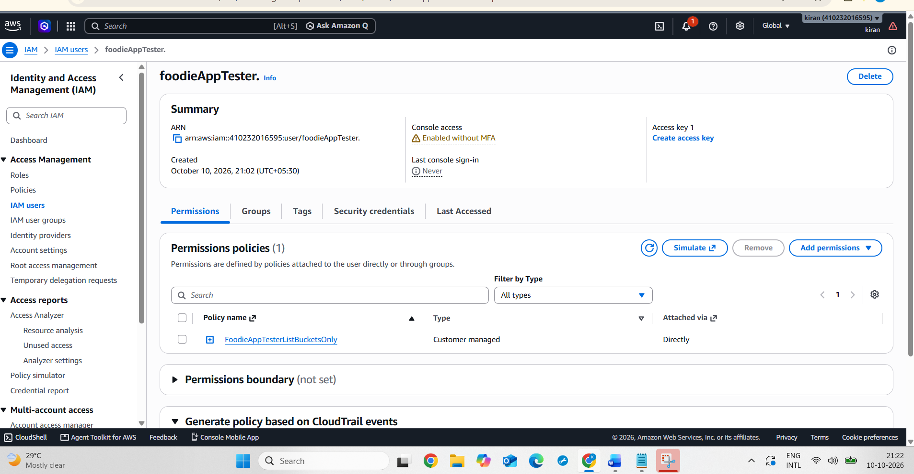
Screenshot : Policy JSON reviewed to identify permissions that may be broader than necessary.
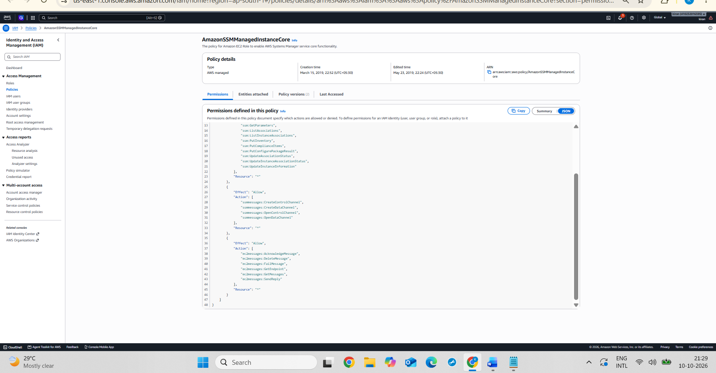

3.
Modify the overly broad permissions you found in the previous task by editing the policy to restrict access only to the required services and actions (for example, allow only read/write to the food menu database and order storage, deny all other actions).
ANS :
Modifying Overly Broad IAM Permissions
To restrict AWS IAM permissions for a Zomato-style food delivery application by following the principle of least privilege.
Steps performed:
- Opened AWS IAM and created a custom policy named ZomatoBackendLeastPrivilege.
- Defined limited permissions for reading food menu data and accessing order records in DynamoDB.
- Restricted S3 permissions to reading and writing files in a specified bucket.
- Reviewed the policy to avoid unnecessary permissions such as deleting data or accessing unrelated services.
Security Benefit: Restricting permissions to specific actions and resources reduces unnecessary access and improves the security of the application.
Conclusion: A custom least-privilege IAM policy was prepared for a food delivery backend to limit access to the required database and storage operations.
Screenshot : JSON document of the ZomatoBackendLeastPrivilege policy
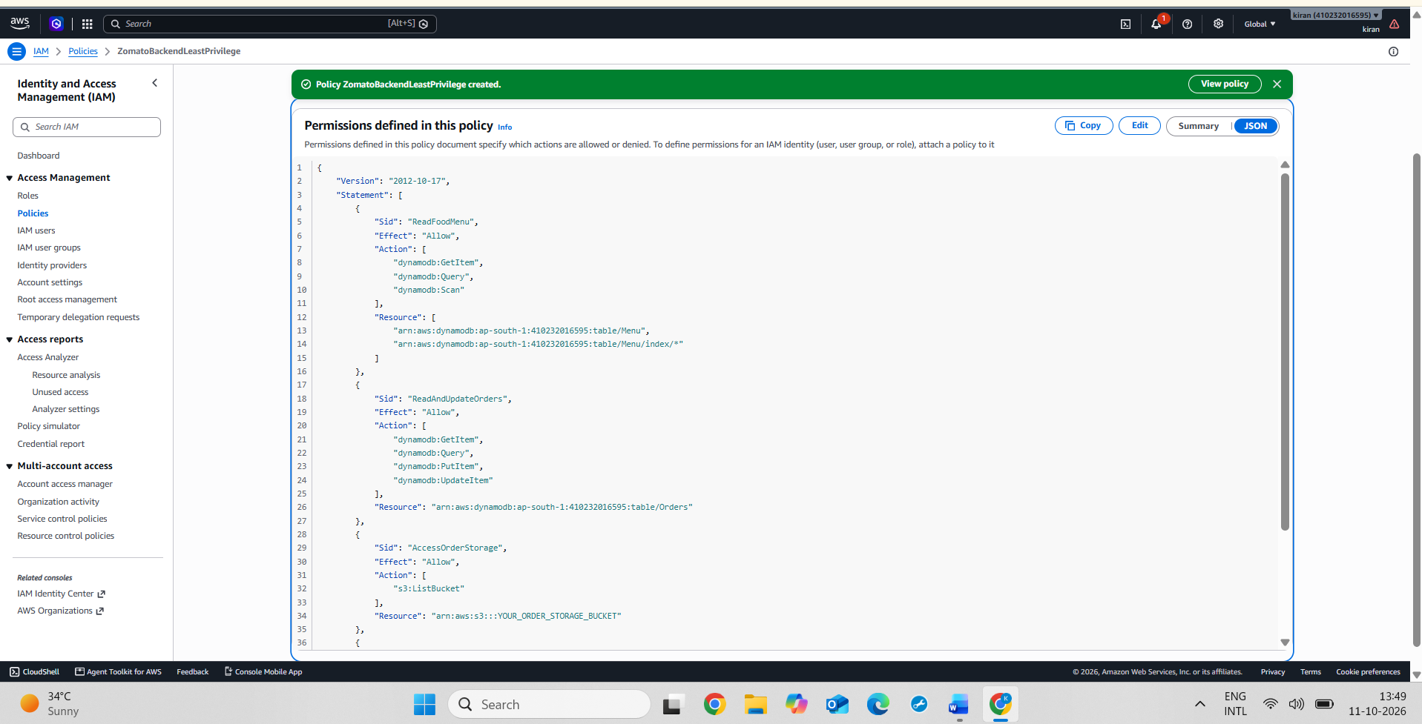
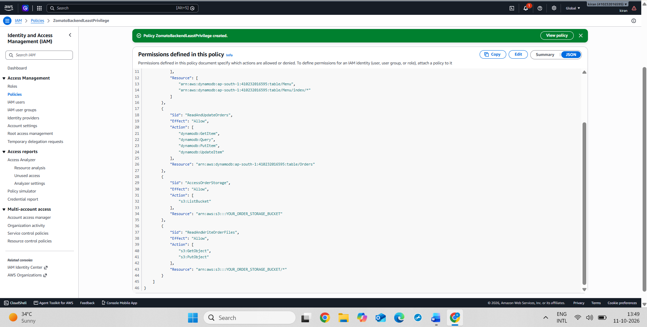
Screenshot : ZomatoBackendLeastPrivilege policy displayed in the AWS IAM Policies list.
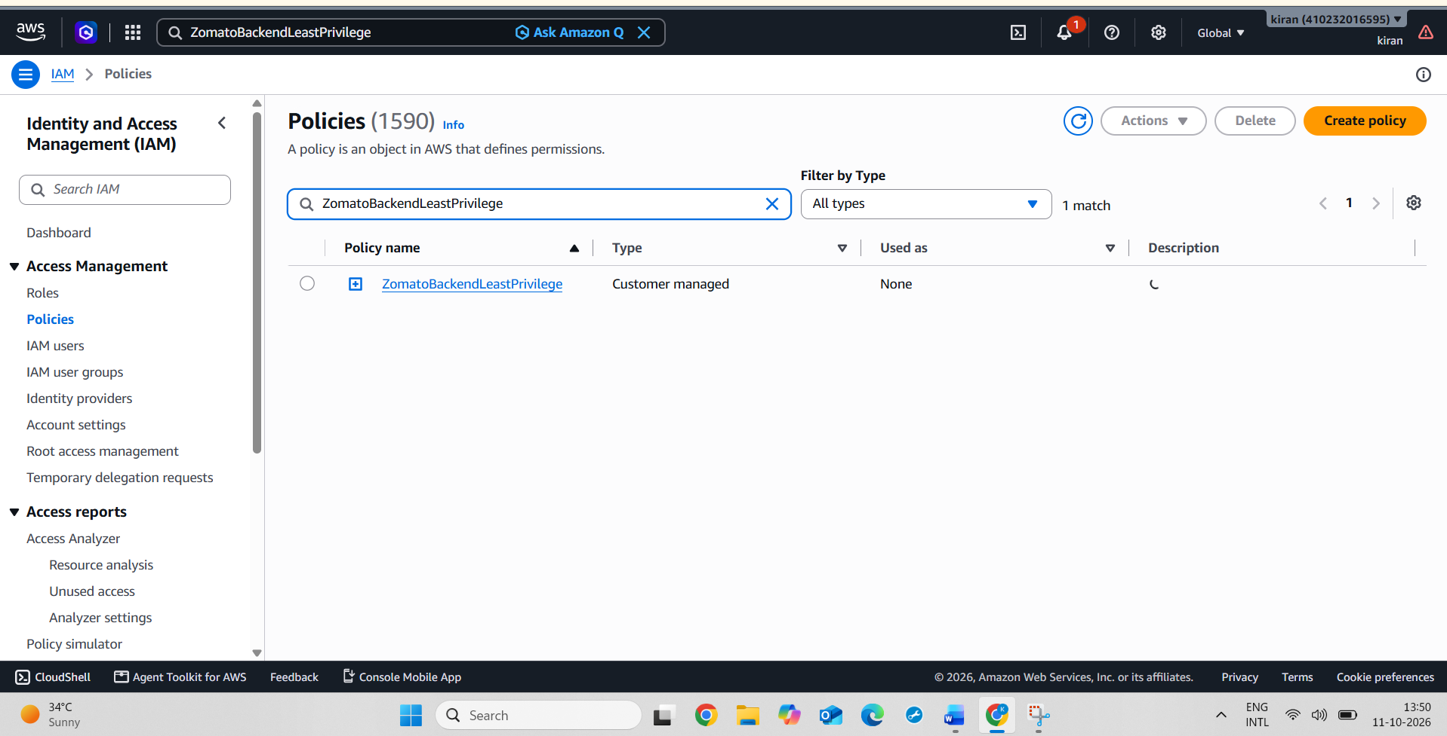
4.
Use ChatGPT or Copilot to generate a least-privilege IAM policy JSON for a user who only needs to upload profile pictures to a 'user-profile-pics' storage bucket. Review the generated policy and apply it to a test user.<br><br><em><strong>Hint:</strong> Ask the AI tool to explain each permission in the policy so you understand what it allows.</em>
ANS :
Steps :
1. Generated an IAM policy JSON using ChatGPT.
2. Reviewed the policy and understood the purpose of each permission.
3. Created a test IAM user named "profile-pic-uploader".
4. Created a custom IAM policy named "UserProfilePicsUploadOnly".
5. Configured the policy to allow the "s3:PutObject" action only for objects in the "user-profile-pics" bucket.
6. Attached the policy to the test IAM user.
7. Checked the S3 bucket and tested the upload permission using the IAM Policy Simulator.1
Result: A custom least-privilege IAM policy was created and attached to the test user. The policy grants permission to upload objects to the specified S3 bucket without granting additional permissions to delete or download objects.

Conclusion: The practical demonstrated how AWS IAM policies can restrict users to only the permissions required for their tasks, improving cloud security through the principle of least privilege.
Screenshot : test IAM user named profile-pic-uploader was created to test the least-privilege S3 upload policy.
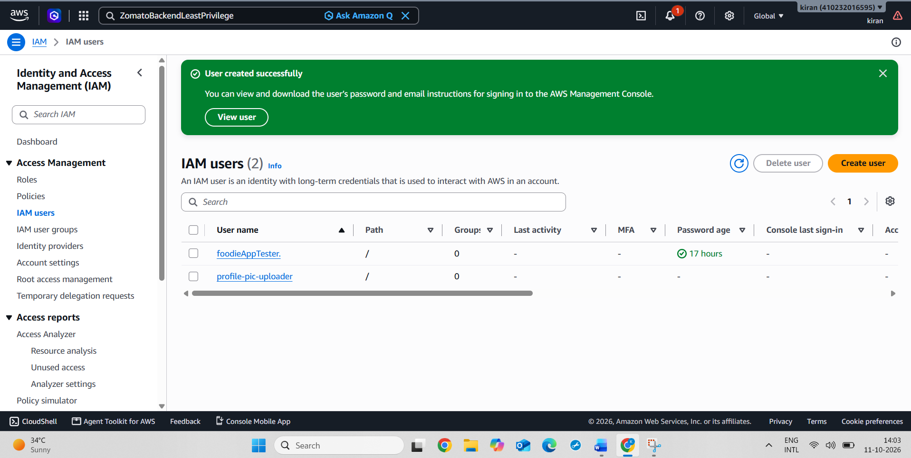
Screenshot : A custom IAM policy was created with the minimum required S3 permission, s3:PutObject, restricted to objects in the user-profile-pics bucket.
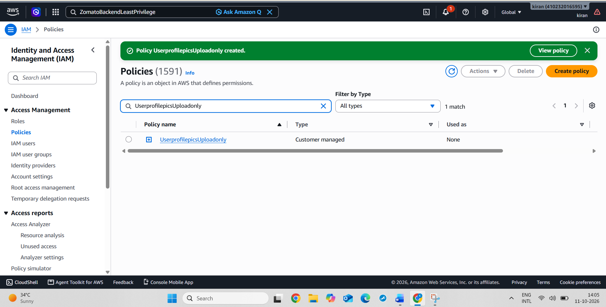
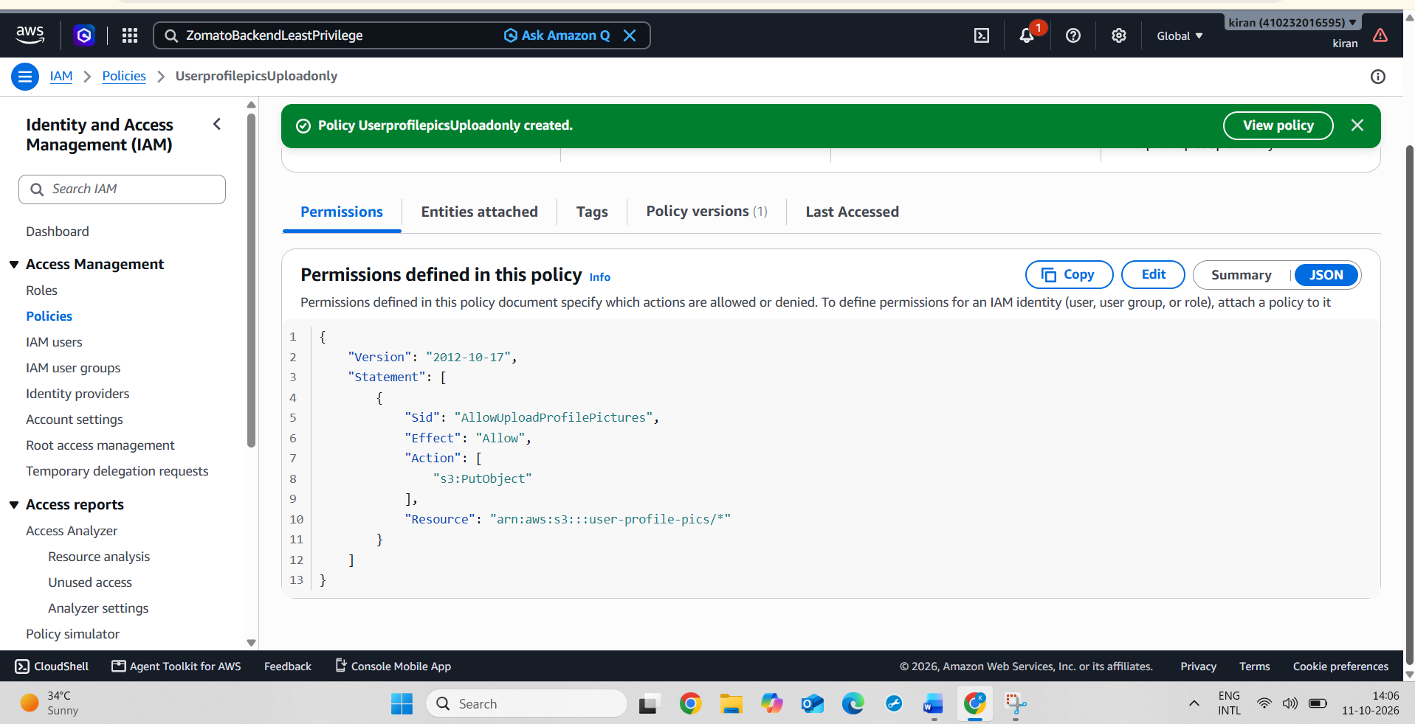
Screenshot : The custom least-privilege policy was attached to the test IAM user to restrict its S3 permissions to profile-picture uploads.
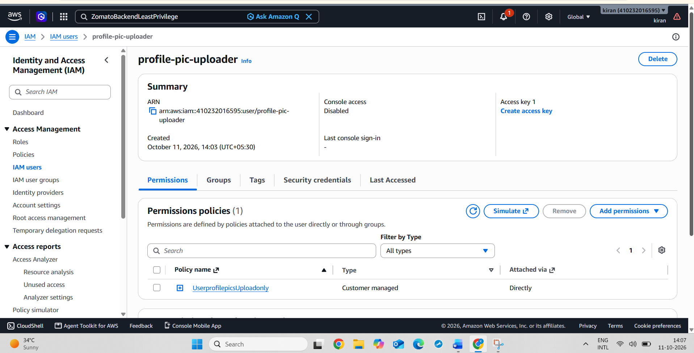
Screenshot : The S3 bucket was checked to confirm that the destination for profile-picture uploads exists.
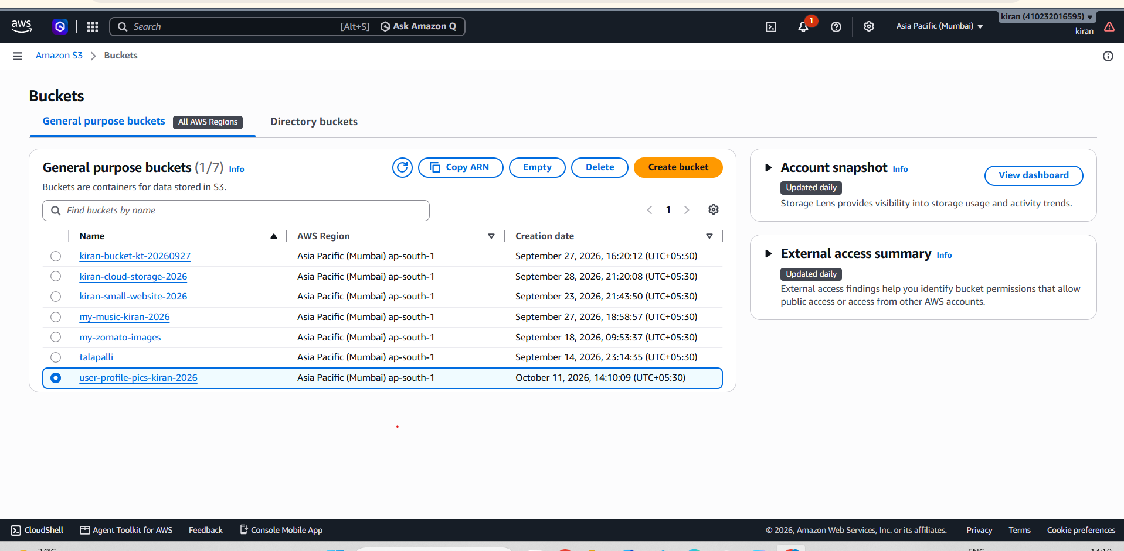
Screenshot : The IAM Policy Simulator verified that the test user profile-pic-uploader is Allowed to upload objects to the user-profile-pics S3 bucket using s3:PutObject and Denied permission to delete objects using s3:DeleteObject. This demonstrates the principle of least privilege in AWS IAM.
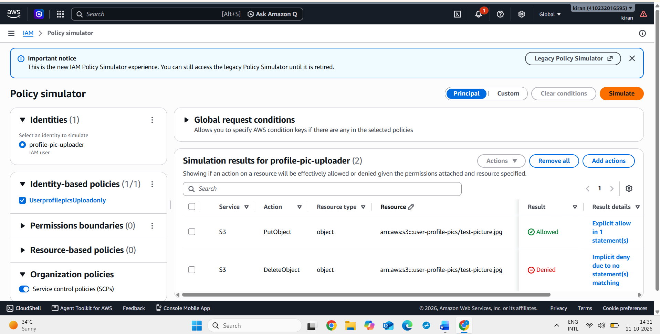

5.
Prepare a 3-minute presentation or a 1-page document showing your IAM user/role configurations, the before-and-after policy changes, and suggest one improvement to further tighten security for a Flipkart-style cloud backend.
ANS :
AWS IAM SECURITY: BEFORE AND AFTER POLICY CHANGES

1. Objective

To understand how AWS Identity and Access Management (IAM) protects a Flipkart-style shopping application's cloud resources by granting users only the permissions they need.

2. IAM User and Role Configuration

IAM User: An identity that can receive permissions to access AWS resources.

IAM Role: An identity that provides temporary credentials to a trusted user, application, or AWS service.

Example: A shopping application's backend can use an IAM role to upload profile pictures to an S3 bucket.

3. Before Policy Changes

Before applying a least-privilege policy, a user with unnecessarily broad permissions could potentially upload, delete, or access objects beyond their requirements. This creates a security risk.

Note: This describes a possible risk scenario, not a claim that broad permissions were actually configured.

4. After Policy Changes

A custom IAM policy was created and attached to the profile-pic-uploader user.

The policy allows:

Action: s3:PutObject

Resource: arn:aws:s3:::user-profile-pics/*

The IAM Policy Simulator showed:

PutObject — Allowed

DeleteObject — Denied

This demonstrates the principle of least privilege.

5. One Improvement to Further Strengthen Security

Enable Multi-Factor Authentication (MFA) for human users who sign in to the AWS Console. For applications, use IAM roles and temporary credentials instead of long-term access keys wherever possible.

6. Conclusion

AWS IAM helps protect cloud resources by controlling who can access them and what actions they can perform. Least-privilege policies, MFA, and IAM roles improve security for a Flipkart-style cloud backend.

